Run the test first for now (1 test case only)

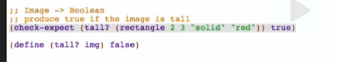

Comment out stub, label



**Inventory**

Template



Copy, comment out and label the template

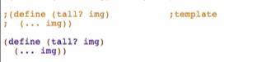

**Code body**

* 2 cases!
  + One for tall cases
  + One for not tall cases
* Use if





* 

Try running: 

But we have a highlighted part here:

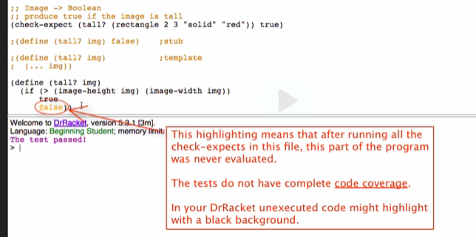

* You don’t have enough test cases!
  + There should be no unexecuted code!

Adding test for NOT tall



Run again: 

But we’re not done yet! What if the sides are equal?

* This is where boundary cases are thought of
* This can be a guide that when dealing with Boolean, we need to have at least 3 test cases esp. when the comparison operator does not evaluate an ‘=’

What to do when it happens?

* Write an example (test) right away
* Update all affected parts of design, often this involves:
  + Purpose and/or
  + Function definition
* Sometimes involves existing tests or even the signature

In this case, we add an example test for the same side



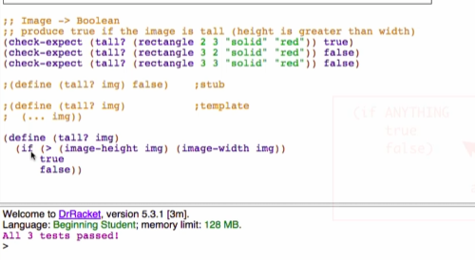

If you have a return value of simply true or false, just return the condition/question itself

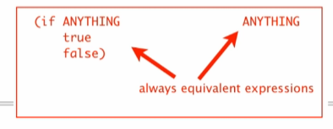

Final:

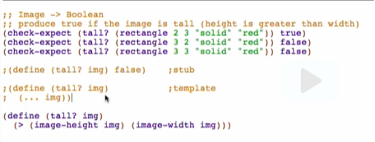

Can be a guide in determining number of test cases:

